ST. ERVAN PARISH COUNCIL
Jacqui Peskett
Parish Clerk

Email: stervanpc@outlook.com
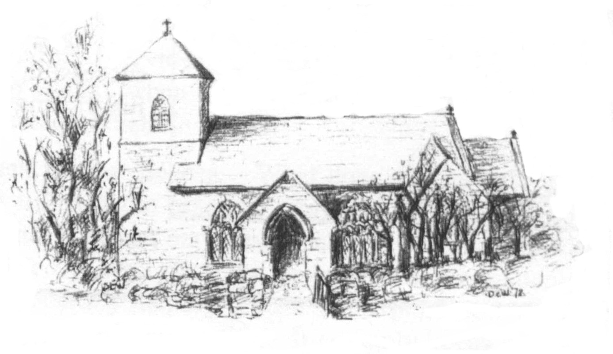

25th October 2023

I hereby give notice that the ORDINARY MEETING of ST ERVAN PARISH COUNCIL will be held at St Ervan Village Hall on Tuesday 7th November 2023 @ 7pm

All members of the Council are herby requested to attend for the purposes of considering and resolving upon the business about to be transacted at the meeting as set out in the agenda.

Jacqui Peskett
Clerk/RFO to St Ervan Parish Council

Public Participation
AGENDA

Apologies and Announcements

Declarations of interest

Minutes of St Ervan Parish Council Meeting 5th September 2023

Matters Arising & Correspondence

Planning Applications

Items for Information

Highways

Finance

Date Of Next Meeting: Tuesday 2nd January 2024 @ 7pm

